Model Weight Initialization
The model's weights were initialized using specific strategies tailored to the architectural role of each layer and the preservation of variance during training:
- Layer Normalization: We applied a standard initialization where the gain was set to 1 and the bias to 0, ensuring that normalization begins from a neutral identity transformation.
- Embedding Layer: Weights were sampled from a truncated normal distribution, N(0, 0.02^2), to provide a stable starting point for the high-dimensional latent space.
- Attention Mechanisms: To optimize efficiency, a single unified matrix was utilized for all Key, Query, and Value (KQV) projections across all heads for each layer. These matrices followed the same N(0, 0.02^2) distribution, while their associated biases were initialized to 0.
- MLP Linear Layers: We employed Kaiming Normal Initialization for the Feed-Forward Network (FFN). By setting the standard deviation to sqrt(2 / input_dim), we accounted for the signal attenuation typically caused by ReLU-like non-linearities, thereby maintaining consistent variance across successive layers.

English and Hebrew Dataset Training
Base Model Training
The baseline model was evaluated using a configuration consisting of 6 layers and 6 heads, with an embedding dimension of 192 and an MLP hidden size of 768 ($192 \times 4$). The architecture concluded with a final linear layer of 66 functions, representing each of the 66 tokens in the vocabulary. Totaling approximately 2.5 million parameters, the model utilized a sequence length of 128 tokens and implemented Pre-Layer Normalization.
Training was conducted on the English dataset using the AdamW optimizer with a learning rate of 5e-4. The optimizer hyperparameters were set to β1 = 0.9 for momentum and β2 = 0.95 for adaptive scaling, with the maximum gradient norm clipped at 0.1 to ensure numerical stability. Over the course of 50,000 batches, with a batch size of 64 resulting in a total of 3,200,000 training sequences, the model achieved a final training loss of 0.27. The loss exhibited a consistent downward trajectory throughout the duration of the training, indicating steady optimization.
To enhance generalization, a subsequent experiment introduced dropout layers with a dropout probability of 0.1 immediately following the initial embedding and after each causal self-attention mechanism. This addition resulted in a slightly higher final loss of 0.31 over the same 50,000-batch interval. This increase was expected, as dropout serves as a regularization technique that prevents overfitting by injecting stochastic noise into the learning process, effectively trading a marginal degree of training optimization for increased model robustness and better performance on unseen data.

Architectural Scaling and Hyperparameter Optimization
To further optimize performance, a series of expansive experiments were conducted, culminating in a refined model configuration. The architecture was scaled to 7 layers and 8 heads, with the embedding dimension increased to 256 and a corresponding MLP hidden size of 1,024. The decision to add a seventh layer was specifically intended to evaluate whether providing the model with an additional learnable transformation would improve performance and expressive capacity. Furthermore, the shift to dimensions in powers of two was implemented to better align with hardware memory layouts, thereby optimizing computational throughput on GPU. In total, the model consisted of approximately 5.13 million parameters.
A critical observation during baseline testing was that the loss became increasingly erratic in the later stages of training. We hypothesized that although the AdamW optimizer employs per-parameter learning rate scaling via the second moment, the global learning rate of 5e-4 remained too high as the model approached a local minimum. We hypothesized that this caused the optimizer to overshoot the target, leading to instability despite its adaptive mechanisms. To resolve this, we implemented a cosine annealing scheduler over the 50,000-batch duration. This allowed for a more controlled reduction in the global learning rate, enabling the model to converge smoothly as it neared the minimum.
Under these optimized conditions, the model achieved a minimum loss of 0.118 at approximately 42,000 batches out of total 50,000 allowed, with each batch consisting of 64 sequences, representing roughly 2,688,000 processed sequences. At this stage, the loss stabilized, likely due to either the learning rate reaching its lower bound or the model achieving its maximum representational capacity for the given architecture.
Applying the same hyperparameters to the Hebrew dataset yielded an even lower minimum loss of 0.095 after the full 50,000-batch duration. It should be noted that the Hebrew configuration considered a vocabulary of 159 tokens, bringing the total parameter count to approximately 5.18 million. While these architectural and scheduling adjustments significantly improved the final loss and mitigated training instability, they necessitated a longer training duration and increased computational overhead compared to earlier iterations. This was a direct result of the increased layer count and expanded dimensions, a necessary trade-off for achieving higher model precision.
Generalization and Validation Analysis
To evaluate the model's ability to generalize beyond the training corpus, we conducted further testing using a 90/10 train-validation split on the original training data. Special care was taken to maintain paragraph integrity within each set to preserve local context. Despite the architectural optimizations previously identified, the results indicated significant overfitting.
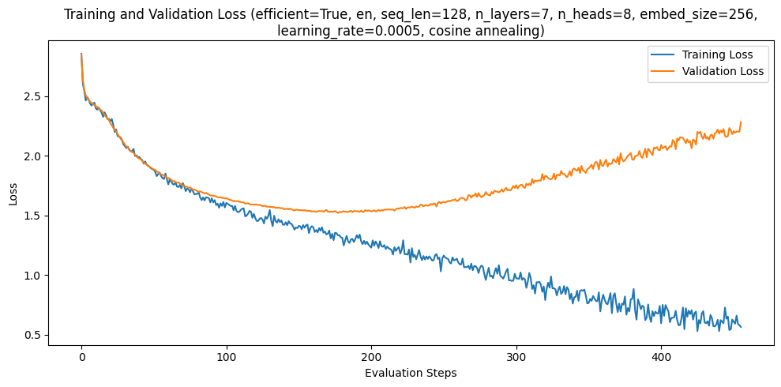
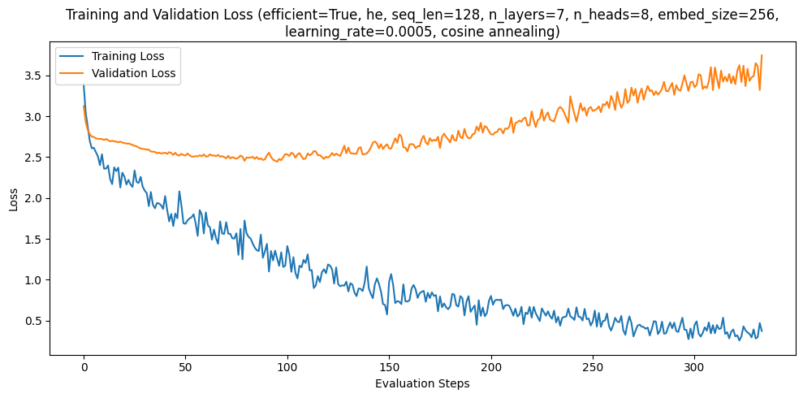
In the English dataset, the training loss continued a sharp descent, reaching a minimum of 0.5 before the process was halted. Conversely, the validation loss plateaued and eventually began to diverge, reaching a minimum of approximately 1.5. The results for the Hebrew dataset were more pronounced, as while the training loss dropped effectively to around 0.5, the validation loss struggled to descend and eventually hit a threshold of 2.5. To manage this divergence between training and validation performance, we implemented an early stopping protocol that terminated training once the validation loss exceeded 1.5 times its recorded minimum. Utilizing the optimized hyperparameter configuration highlighted previously, training on the English dataset was halted after approximately 4,800 batches, while the Hebrew training was terminated at approximately 3,700 batches.
To optimize the model and address the performance gap, we implemented a random search algorithm to identify the hyperparameter configuration most conducive to minimizing validation loss. The search space was defined by several key architectural and training variables: sequence lengths were sampled from {32, 64, 128, 256, the number of layers from {6, 7, 8}, and the number of heads per layer from {6, 7, 8}. Additionally, the learning rate was sampled uniformly from the interval [1e-4, 5e-4].
To maintain structural consistency and ensure the embedding dimension was always divisible by the number of heads for proper concatenation, the embedding size was dynamically set to 32 times the number of heads. Following standard Transformer conventions, the MLP hidden dimension was consistently scaled to four times the embedding dimension. This stochastic approach allowed for a broad exploration of the design space, testing the interaction between model depth, attention complexity, and temporal resolution. For each dataset, a total of ten unique combinations were trialed to determine the optimal configuration. The scope of these trials was intentionally constrained to ten iterations per dataset due to limited computational resources and the associated costs of extended training runs. The following graphs summarize the training and validation losses achieved.
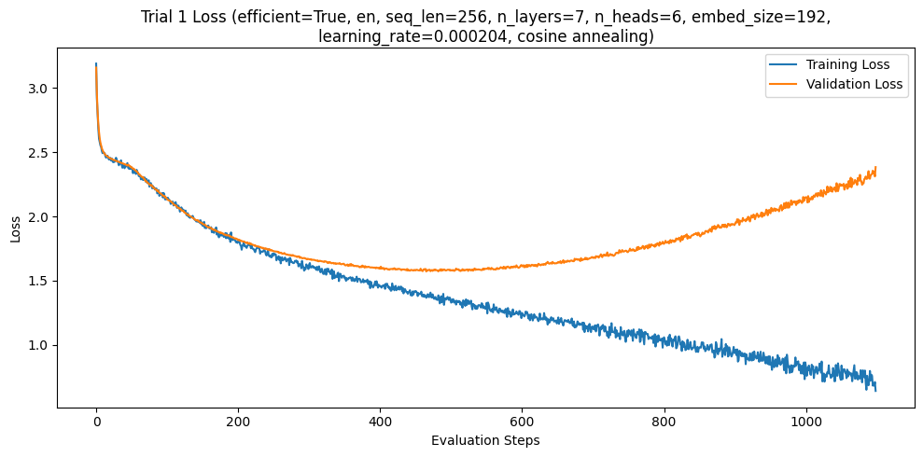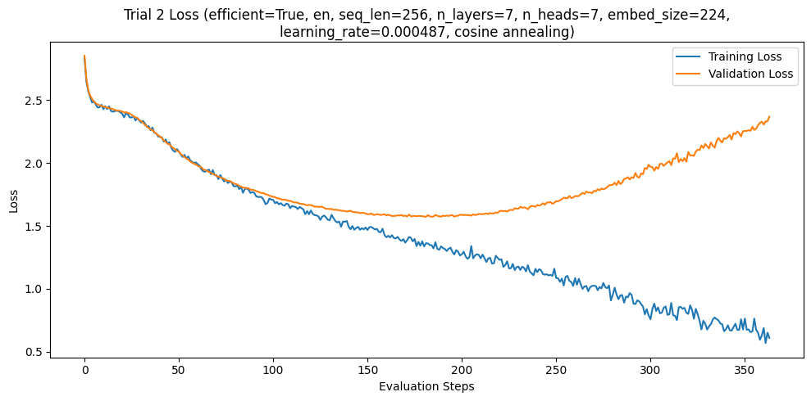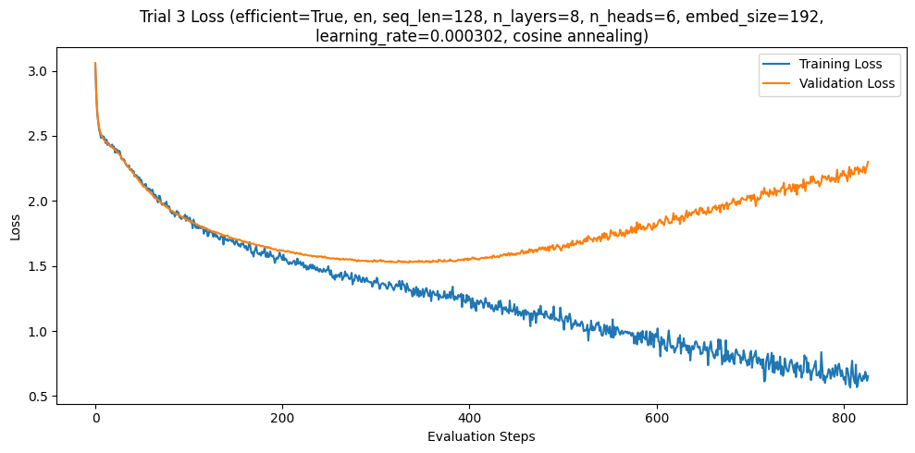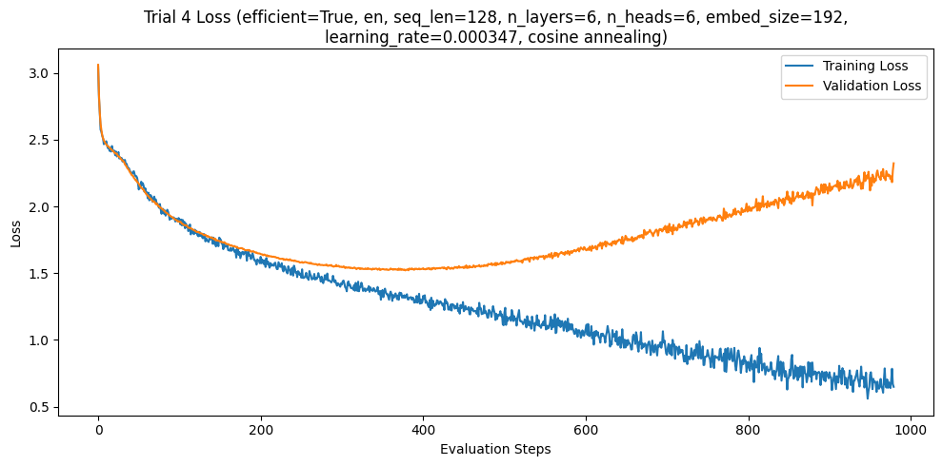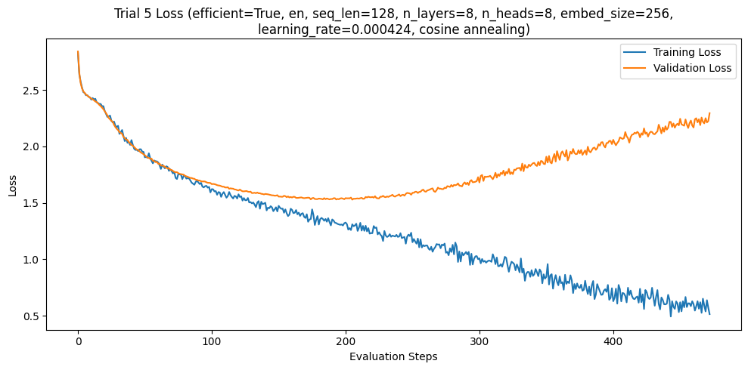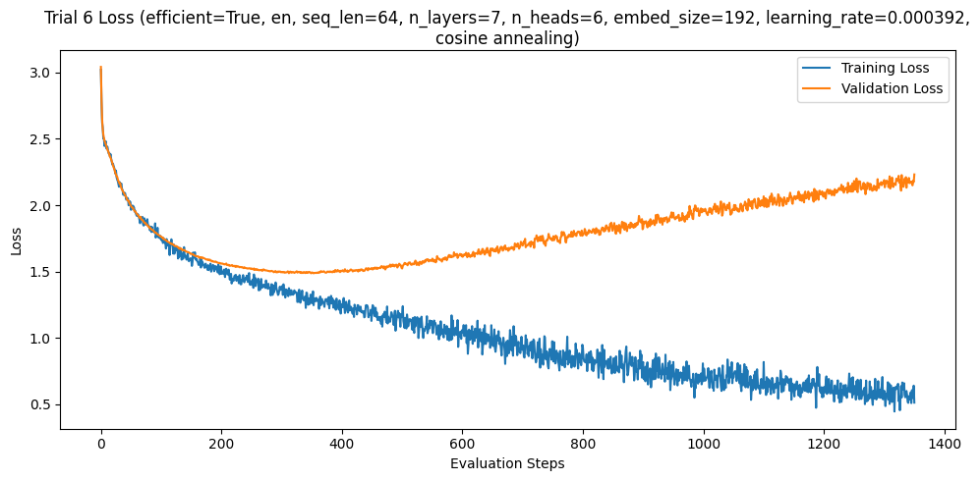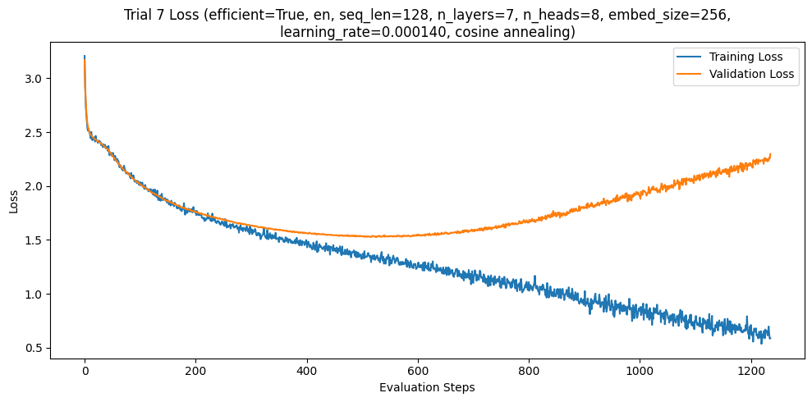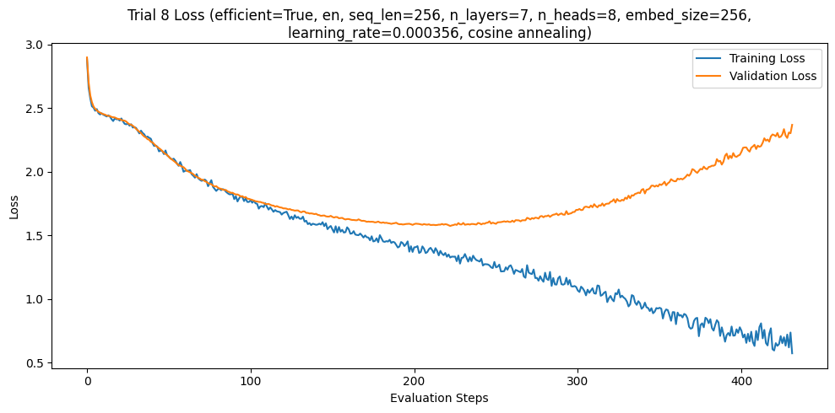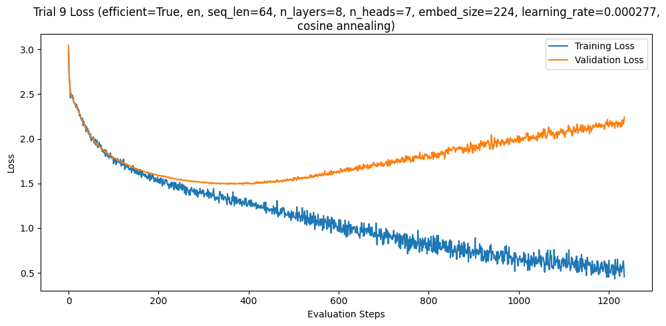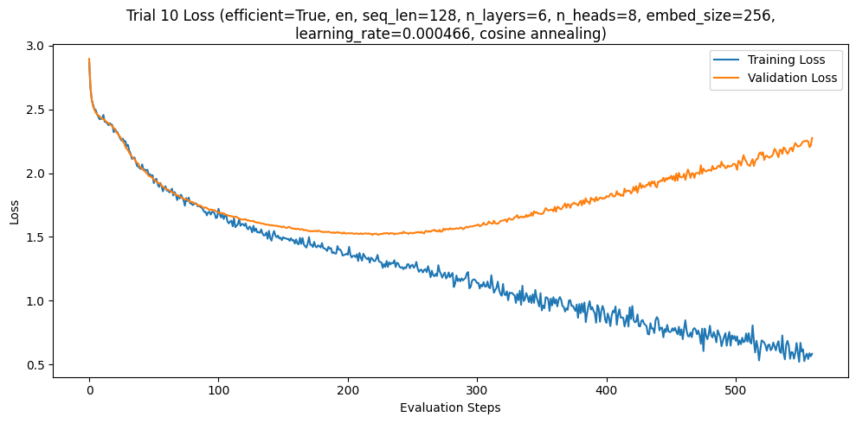
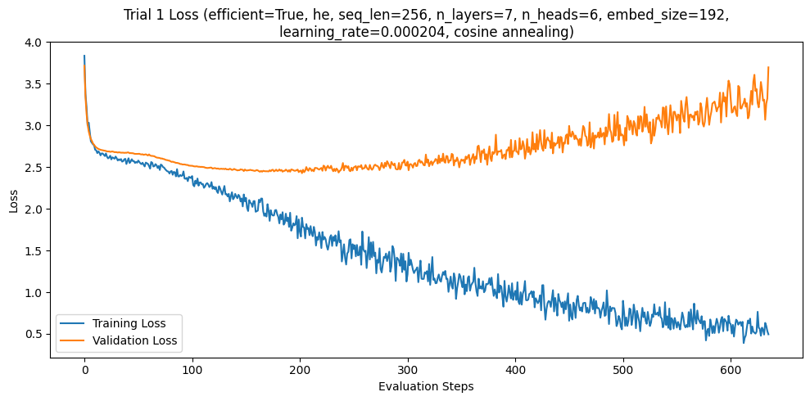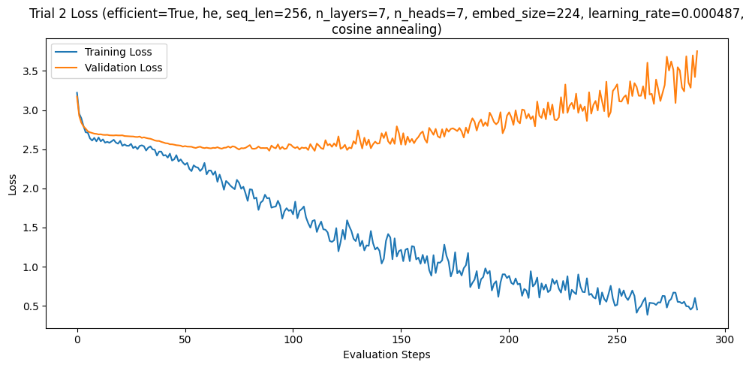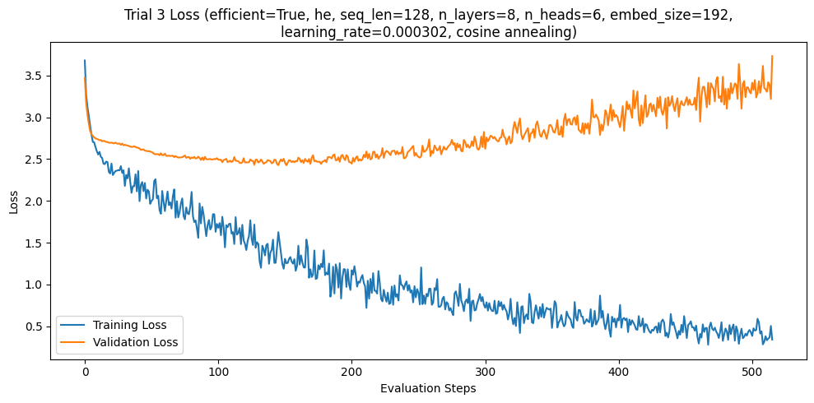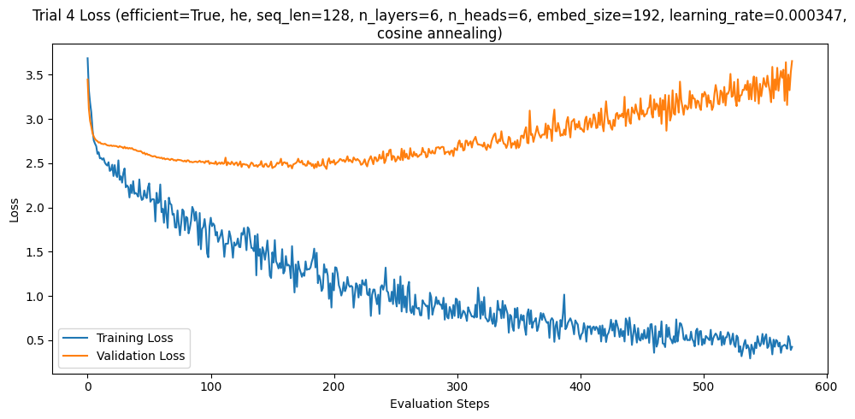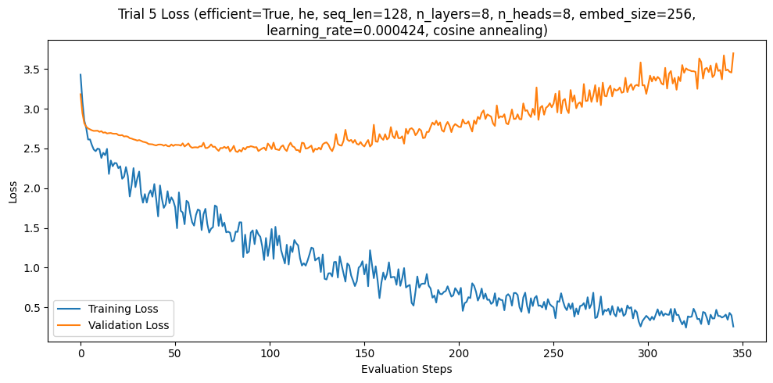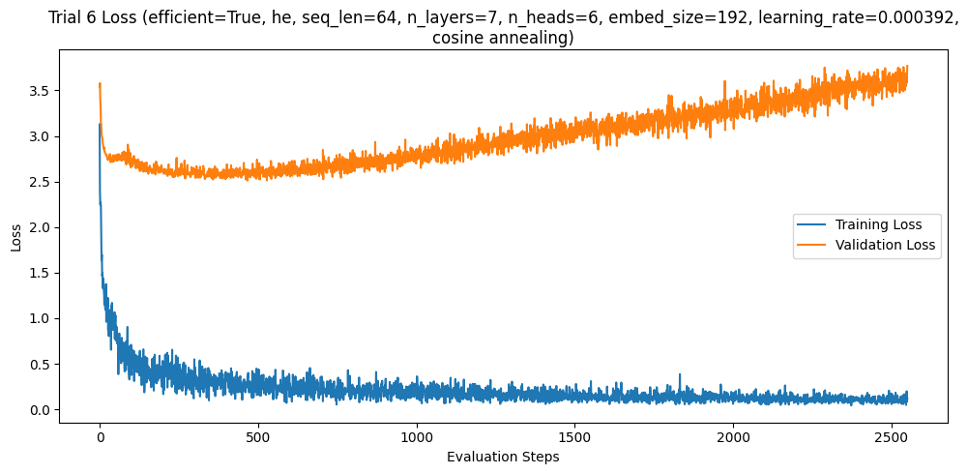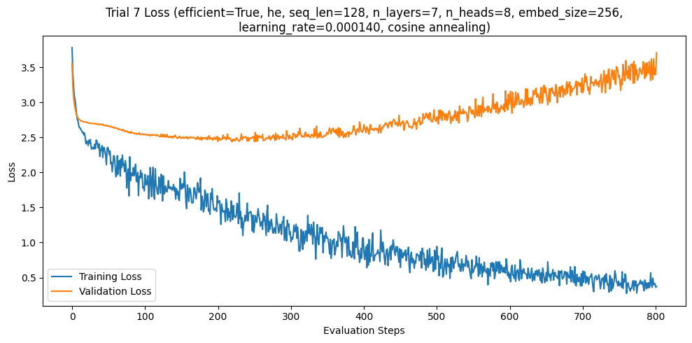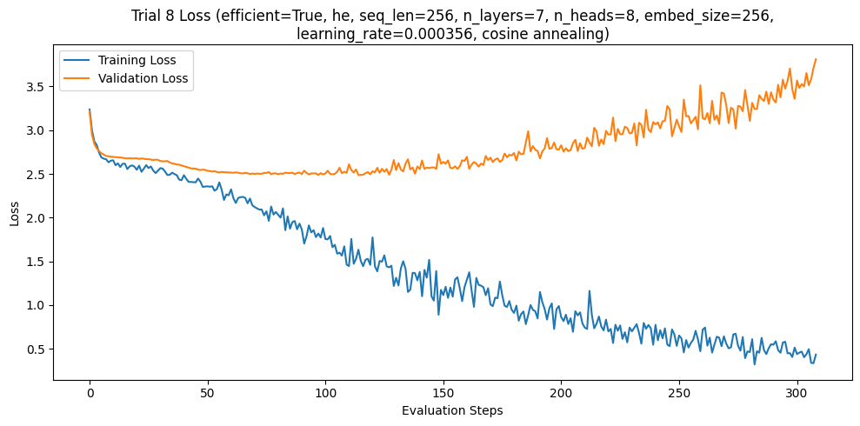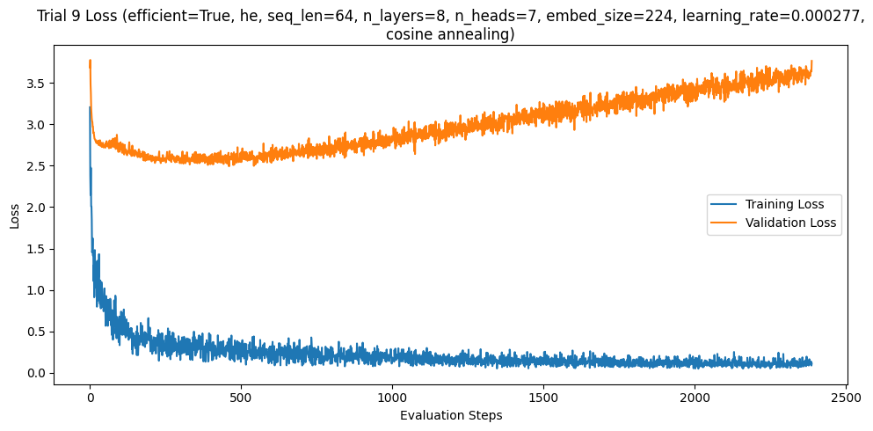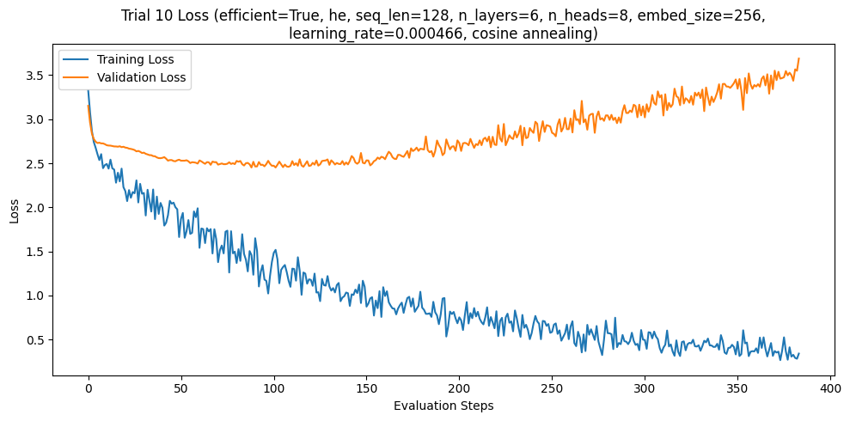
Across all training iterations for both the Hebrew and English datasets, the validation curves consistently mirrored the patterns observed in the initial hyperparameter tests. The validation loss typically descended to a minimum of approximately 1.5 for English and 2.5 for Hebrew before reversing trajectory and rising until the early stopping criteria were met.
Factors Influencing Generalization
Several hypotheses are proposed to explain this performance gap and the difficulty in achieving lower validation metrics:
- Dataset Scale: The current training sets may lack the necessary volume and diversity to adequately represent general linguistic patterns, leading the model to optimize for specific nuances of the training data rather than universal features.
- Tokenization Granularity: We utilized a character-level tokenization scheme where each letter is treated as an individual token. This approach may limit the model's ability to identify higher-level semantic structures and patterns that are more easily captured by sub-word or BPE (Byte Pair Encoding) tokenization methods.
- The Nature of Overfitting in LLMs: It remains an open question in the research community whether overfitting during the pre-training phase of Large Language Models (LLMs) functions identically to overfitting in traditional machine learning. While the divergence between training and validation loss is a classic indicator, the relationship between "memorization" and "emergent reasoning" in autoregressive models is still being actively explored.
Sequence Length and Learning Efficiency
In a comparative analysis of different sequence lengths, a consistent pattern emerged where longer sequence lengths yielded a faster reduction in loss per batch, while shorter sequences required a significantly higher number of batches to converge.
- Gradient Signal Density: We hypothesize that longer sequence lengths provide a higher signal-to-noise ratio for each weight update. Because the model can attend to a broader context in a single pass, the resulting gradients are more representative of the language's overall structure, allowing for more efficient optimization.
- Contextual Truncation: For the shorter sequences, we hypothesize that the limited contextual window forced the model to frequently predict tokens based on incomplete sentence fragments. While the loss still decreased consistently, proving the model was successfully extracting patterns, this "contextual truncation" necessitated a larger volume of updates to achieve the same degree of convergence observed in longer-sequence trials.

In summary under the conditions of validation loss, the best model for English dataset were trained on sequences of length 64, 7 layers with 6 heads, an embedding dimension of 192, an mlp dimension of 768 and a initial global learning rate of about 3.92e-4 (training trial 6)

